Student’s name | …………………………………………………….…… | Grade | 1
Subject | Computer | Week No. | 1
Lesson Title | introduction | Unit
Worksheet No. ( 1 ) (Answer)

Instruction: Match the following

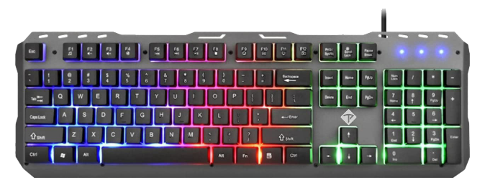 | Speaker
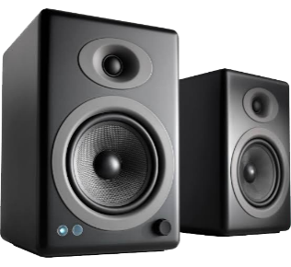 | MONITOR
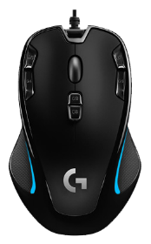 | KEYBOARD
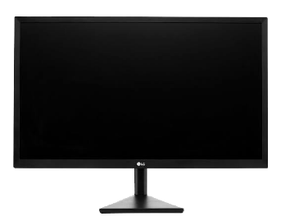 | MOUSE

Good Luck

